**A Seminar Report**

On

“Project Tracking System”

Submitted to

**Savitribai Phule Pune University, Pune**

In partial fulfilment for the award of the Degree of

Bachelor of Engineering

in

**Information Technology**

by

Sejal Kushte (T21284 Div:- II)

Under the guidance of

Prof. R. H. Borhade



**Department of Information Technology**

**STES’s, Smt. Kashibai Navale College of Engineering,**

Vadgaon (BK), Pune, 411 041.

2021-2022 (SEM-I)



**CERTIFICATE**

This is to certify that the seminar report entitled “Project Tracking System” being submitted by Sejal Kushte (T21284 (II)) is a record of bonafide work carried out by him/her under the supervision and guidance of Prof. R. H. Borhade partial fulfillment of the requirement for **TE (Information Technology)** ˆ2019 course of Savitribai Phule Pune University, Pune in the academic year 2021-2022.

Date: / / 2021

Place: Pune

|  |  |
| --- | --- |
| Prof. R. H. Borhade  **Guide** | Prof. R. H. Borhade  **Head of the Department, IT** |
| Dr. A. V. Deshpande  **Principal, SKNCOE, Pune** | |

This Project Based Seminar report has been examined by us as per the

Savitribai Phule Pune University, Pune requirements at **Smt. Kashibai Navale College of Engineering, Pune-41** on ________________

Internal Examiner External Examiner

**ACKNOWLEDGEMENT**

I would like to express our gratitude to Prof. R. H. Borhade Head of Department of IT

Department who enabled us to complete this seminar related work successfully in all aspects. We also express our sincere thanks to Dr. A. V. Deshpande Principal of SKNCOE. We are grateful to Prof. R. H. Borhade (Project Guide) for providing importance Guidance regarding this seminar. We would like to thank Prof. A. *. Narote who provide important guidance during seminar preparation.

We would like to thank to all the staff members, both teaching and non-teaching staff who helped us in all possible way to make this seminar report successful.

(Sejal Kushte T21284)

**TABLE OF CONTENTS**

|  |  |  |
| --- | --- | --- |
| **Abstract** | | v |
| **List of Figures** | | vi |
| **List of Tables** | | vii |
| **Abbreviations** | | viii |
| 1. **INTRODUCTION** | | 1 |
|  | 1.1 Introduction to Project topic |  |
|  | 1.2 Motivation behind project topic. |  |
|  | 1.3 Aim and Objective(s) of the project work |  |
|  | 1.4 project Title |  |
|  |  |  |
| 1. **BACKGROUND STUDY OF Seminar Title/Topic** | |  |
|  | 2.1 Introduction to Seminar Topic. |  |
|  | 2.2 Motivation behind seminar topic. |  |
|  | 2.3 Aim and Objective(s) of the seminar work |  |
|  | 2.4 Literature Survey |  |
|  | 2.1 Gap Analysis |  |
| 1. **SEMINAR RELATED OTHER CHAPTERS** | |  |
|  |  |  |
|  |  |  |
| 1. **CONCLUSION** | |  |

**ABSTRACT**

The Student Online Project Planning and Tracking System, SOPPTS, is an online system designed and implemented to enhance the communication avenues and the project planning/tracking requirements of student projects for the all college. This paper presents the design and assessment of this tool SOPPTS has been designed and field-tested to provide real -time feedback from faculty on student project progress, to offer online guidance for project planning and to produce automated tracking of student projects. The tool assessment included interviews of both students at the undergraduate and graduate level and faculty. The interview was a set of specific questions chosen to document each participant's experience and impressions of utilizing SOPPTS. Data evaluation consisted of compiling the reoccurring themes during the interview process. The major themes that emerged are the increased efficiency in developing, recording and tracking of student project plans, the visibility and immediate accessibility of this information and the improved and timely communication among the student team members, faculty and client partners. With the improved access to information and facilitated communication through SOPPTS, the project planning and tracking skills for the software development teams improved. Moreover, the informal aspects of team communication and synergy, factors that can be as important as the technical aspects, were enhanced.

***Keywords— SOPPTS, PTS.***

**LIST OF FIGURES**

|  |  |  |
| --- | --- | --- |
| a | Lifecycle of the Project | 10 |
| b | System Architecture | 11 |
| c | Data Flow Diagram | 13 |
| d | Menu Tree of the System | 16 |
| e | Class Diagram for Threshold Group Signature | 36 |
| f | Use Case Diagram For Group Formation |  |

**ACRONYMS**

ART Adaptive Resonance Theory

AVHRR Advanced High Resolution Radiometer

CEOS Committee on Earth Observation Satellites

cp ‘change’ pixels

CSA Canadian Space Agency

DCT Discrete Cosine Transform

DEM Digital Elevation Model

DInSAR Differential Interferometric SAR

DN Digital Number

Notes: Acronyms should be alphabetically sorted

**Chapter 1**

**INTRODUCTION**

1.1 Introduction to Project

Our project is Project Tracking System; Project Tracking System is a system about tracking the process of project of students. In which, there are four login portals. The first one is Admin. Admin is responsible for assigning ProjectIncharge, Project Guide, and Student Groups. Admin monitors on ProjectIncharge. The second login portal is ProjectIncharge. ProjectIncharge has rights to receive project reports and give feedback on the project report as per the student group comes from the Project Guide. ProjectIncharge is also responsible for checking the status of projects. The third main login gateway is Project Guide. Project Guide is responsible for receiving project reports and give feedback on the project report as per the student group comes from the Student Groups. The last login portal is Student Groups which will be responsible for uploading documents, receiving feedback for ProjectIncharge.

Our project topic is Project Tracking System in which we can handle the work load of final year main project in efficient way and also in manageable way for documentatation . It is system that manage all the documents of a final year project from start to end of the project. First the system will start there is four logins options are available.

1) ADMIN LOGIN

2) PROJECT INCHARGE

3) PROJECT GUIDE

4) STUDENT GROUPS

In which system the first and main login or we can say that attribute is Admin. Admin is person who can first login into the system and set is password and id. And then he assign project incharge, project guide, and assign the students group. Admin can see the overall status of the project. The second most important login is incharge login. After assign the project incharge by the admin ,then that person will login in system as project incharge. Project incharge is then assign the project guide for the student groups. Project incharge receive the project report from project guide, and he or she check the project report and if there is some mistake or any feedback for the project guide then he/she send feedback to the project guide. Also project incharge can see the overall process or we can say that status of project report of every single student group that login into the system. And according to that he/she gives the marks to the student groups.

Then the third login is the project guide login .project guide is firstly login into the system. The project guide is receive the project report from the student groups. Check that project report and if there is some mistake or any other changes so the project guide send feedback to the student groups If there is no such changes in the project report so then project guide send the project report to project incharge . The project guide is also can see the overall process or status of an student groups and give marks according the project report.

Last login in the system or we can say that last main attribute in the system is the student groups. The student groups send the report to the project guide and also receive the feedback from the project guide. The main task for the student groups is upload the project report documents before the deadline end. If student group is not upload the project report on time, so that student group cannot upload that particular documents again in the system, without discussing with project incharge. Student group can see there work status.

1.2 Motivation behind pro ject topic

In every college it is complicated task to keep record of final year project of all departments. And also its headache for teacher to keep exact eye on each student groups . So As per the college requirements we decide to do project tracking system, So every project is stores in this system and teachers are show each project status and give feedback to each project as per its current status.

1.3 Aim and Objectives of the work

* To accuracy in report generation.
* To need user friendly software for managing report.
* Customization available.
* Well featured app that helps in increase efficiency in Project Management.

1.4 Introduction to Seminar Topic

* Project Title: Project Tracking System.
* Jayesh Patil: Online Tracking Of Project.
* Madiha Khan: Monitoring Project Progress.
* Sejal Kushte: Why to use Project Tracking System.
* Harish Suryavanshi: Importance of Project Tracking System.

**Chapter 2**

**BACKGROUND WORK OF Seminar Title/Topic**

Students are expected to write similar or related work already done by vary- iOS researchers. They could also explain existing tools/technologies in this section. There advantages and disadvantages of each method or technique. They should also explain how their project is different from those existing systems. You need to read lot of books/ papers/ magazines for making this survey.

2.4 Literature Survey

**1. IEEE Xplore, 2 April 2003: - Improving project planning/tracking for student software engineering projects through SOPPTS by J. Zhang ,D. Zage , W. Zage**

In general, all groups thought that PTS(project tracking system) was valuable for the student project making and uploading process. Students suggested that all classes require the use of PTS just to use the features of the project tracking system room and the online submission of project documents. For our study, only a few teams from the software engineering class used PTS. It was suggested that all teams be required to use it from the start of the this semester. Additional features requested included providing more online information about the project tracking system and gives help column in PTS.

**2. IEEE Xplore, 6 August 2002:- Software Project Planning Associated(SPPA): a knowledge-based approach for dynamic software project planning and tracking.**

Software project tracking can be one of the most critical activities in the modern software project development process and tracking. Without project tracking software and objective software project plan, the project tracking process cannot be managed in an effective and efficient way. Some software projects never complete anything. Project Guide and project incharge have difficulties to understanding and visualizing the project making process defined in a software project plan. The Software Project Tracking System, developed in the Angluar language, is accessed through standard World Wide Web browsers and designed to assist a software project incharge and project guide in objectively initializing a software project plan and project status, organizing, project documents, scheduling, visualizing, controlling, tracking, predicting and documents collecting. The resources, tasks, schedules and milestones and objectives of the software project tracking are described in the plan. As software development process evolves, measurements are unobtrusively gathered and compliance to the software project plan is reported. Software process effectiveness predictions are made and recommendations are dynamically reported suggesting the software development that should be executed to best comply with the software project plan. The SPPA was developed according to a knowledge-base plan model to allow the manager to keep track of the software plan component. SPPA, with the assistance of a software project planning agent, reports problems and suggests problem solutions to the manager. SPPA helps managers assure that a project is within budget, on time and to customer satisfaction.

**Chapter 3**

**SEMINAR RELATED OTHER TOPICS**

All other details of seminar topic chapter-wise if necessary, including method- ology/algorithms, advantages and disadvantages, applications, enhancements could be added.

3.1 Flow chart

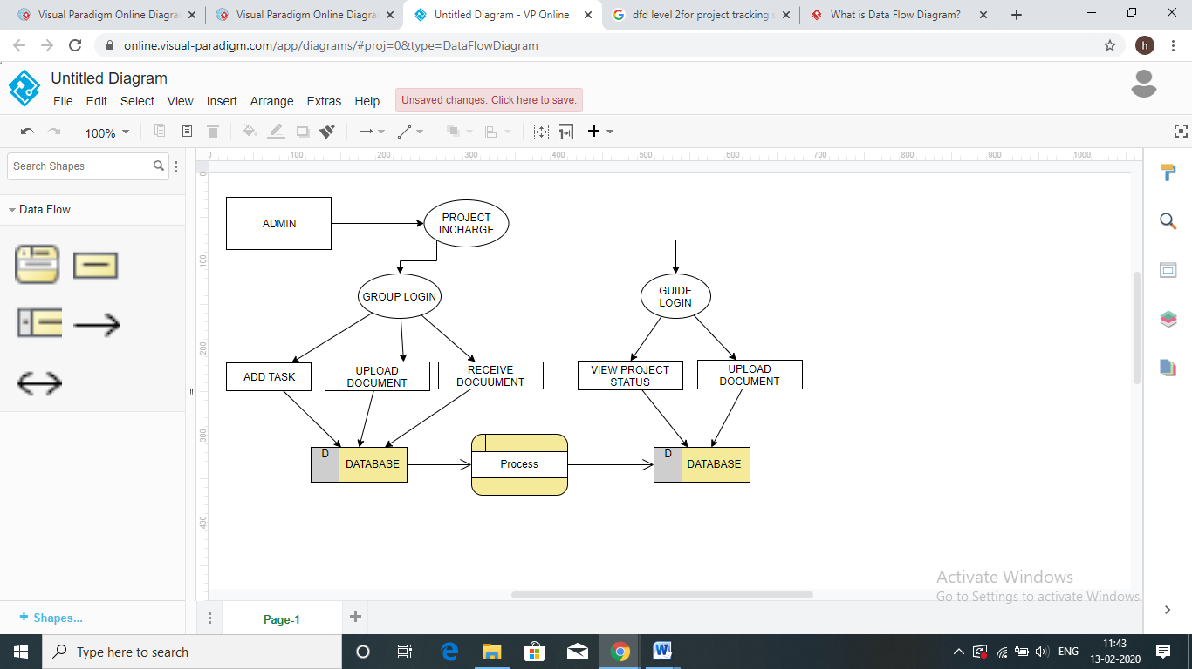

3.2 System Architecture

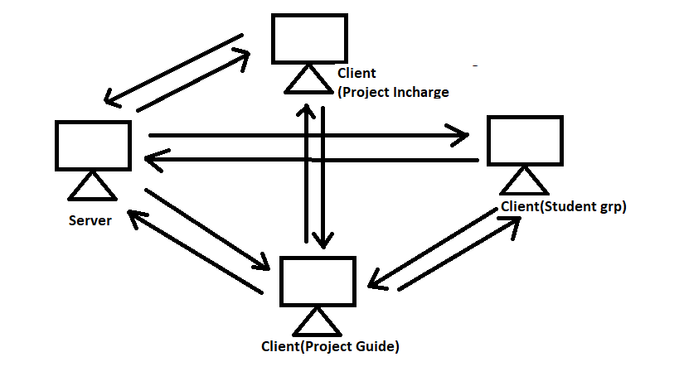

3.3 Advantage

* Accuracy in report generation
* User friendly
* Cost effective
* Increases efficiency

3.4 Feature

* Task Management
* Task Assignment
* Status Tracking
* Report generation
* Timely notifications
* Progress Tracking

3.5 Application

* The project tracking system can be used in colleges and universities to keep a record of all final year projects.
* It can be used to assign work and track the progress remotely.
* This portal will allow students and teachers or guides to interact remotely while giving and receiving feedbacks.

**Chapter n**

**CONCLUSION**

* This software is crucial tool in project tracking, thus every colleges can use this software for better way to storing the project reports and tracking.
* In this seminar we learnt about the potential that a project tracking system has, how it would be implemented and used to make the tracking of projects easier.
* We’ve found that traditional methods of project tracking are not seamless and our project is aimed at making this work hassle free.
* In our final year project we plan to create a web portal to implement the project tracking system.

**REFERENCES**

[1] IEEE Xplore, 2 April 2003: - Improving project planning/tracking for student software engineering projects through SOPPTS by J. Zhang, D. Zage, W. Zage

[2] IEEE Xplore, 6 August 2002: -Software Project Planning Associate (SPPA): a knowledge-based approach for dynamic software project planning and tracking